**Lesson Notes**

1. What is the main purpose of an Operating System?

OS handles the computer hardware. OS handles resource allocation. It handles a standard UI and a standard way to store and browse data. It allows OS to provide ownership control. OS schedules task sharing.

1. What is the difference between Operating System Software and User Application Software?

* Hardware Independence
  + User Interface
  + Applications focus on what is contained and displayed within a window
  + Operating System controls opening / closing / resizing windows and responding to mouse and keyboard actions
  + Operating System provides standard ways to print, save and open files, access the internet, etc.
  + Resource Allocation
  + Applications just ask for what they need (e.g. Memory, Disk Space)
  + Operating System checks for availability and access permission
  + Operating System coordinates resource allocation between applications

1. What is the difference between Operating System Software and Computer Hardware?
   * Same applications can run on different computer hardware
   * Operating System must be configured according to hardware components present in the computer

The operating system is a program whereas the computer hardware is just parts of a computer.

1. What are the main parts of an Operating System?

* System Calls
* Device Drivers
* I/O Manager
* Memory Manager
* Process Manager
* Security Monitor

1. What are some popular operating systems?

**Reference Diagram**

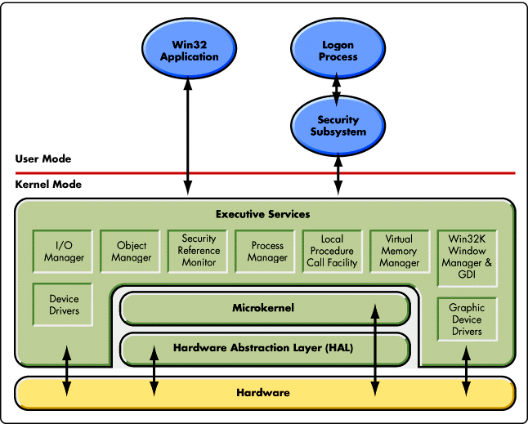

Printer DLL Windows manager Graphics card Ram used CPU Used­ Applications being used Processes being used.

**Student Questions**

1. What is a device driver?
   1. Provide a brief summary

A device driver is a program made to control some sort of hardware connected to a computer computers have built in device drivers for many things.

* 1. List some devices that require a device driver.

Printers, Display devices, CD drives, Mouses, Keyboards and any other outer PC case hardware.

* 1. Provide a label on the reference diagram for the location of a device driver for your graphics card.
  2. Provide a label on the reference diagram for the location of a device driver for a locally attached printer.

1. What is a DLL?
   1. Provide a brief summary

A DLL is a type of file used for holding codes and procedures for windows programs.

* 1. Explain how DLLs are related to user application programs

DLLs hold the way in which windows treats application programs and are vital to them working.

* 1. Provide a label on the reference diagram for the location of a DLL

1. What is a windows manager?
   1. Provide a brief summary

Controls how windows are placed and move in windows.

* 1. Explain how a windows manager is related to user application programs

Controls the windows that users see.

* 1. Provide a label on the reference diagram for the location of a windows manager

1. What is the windows task manager?
   1. Provide a brief summary

Task manager is a program that allows users to see stats about facts and control them.

* 1. List and explain four (4) types of system information provided by the task manager

Task manager provides the Amount of RAM used and the amount of CPU that is being used. It allows you to see the Services being used by your computer and the applications that are open.

* 1. Provide a label on the reference diagram for the operating system components related to each type of information.